M. Sai Harshitha
192424408
CSA0701
SET- 4: Product Inventory Management

1. Procedure to Create a Bar Chart

- Open Tableau Desktop/Public.
- Connect to the Product Inventory dataset.
- Drag Product Name to the Columns shelf.
- Drag Quantity Available to the Rows shelf.
- Select Bar from the Marks card.
- Click Show Mark Labels.
- Rename the chart title as "Product Inventory".
- Label the X-axis as Product Name and the Y-axis as Quantity Available.
- Save the worksheet
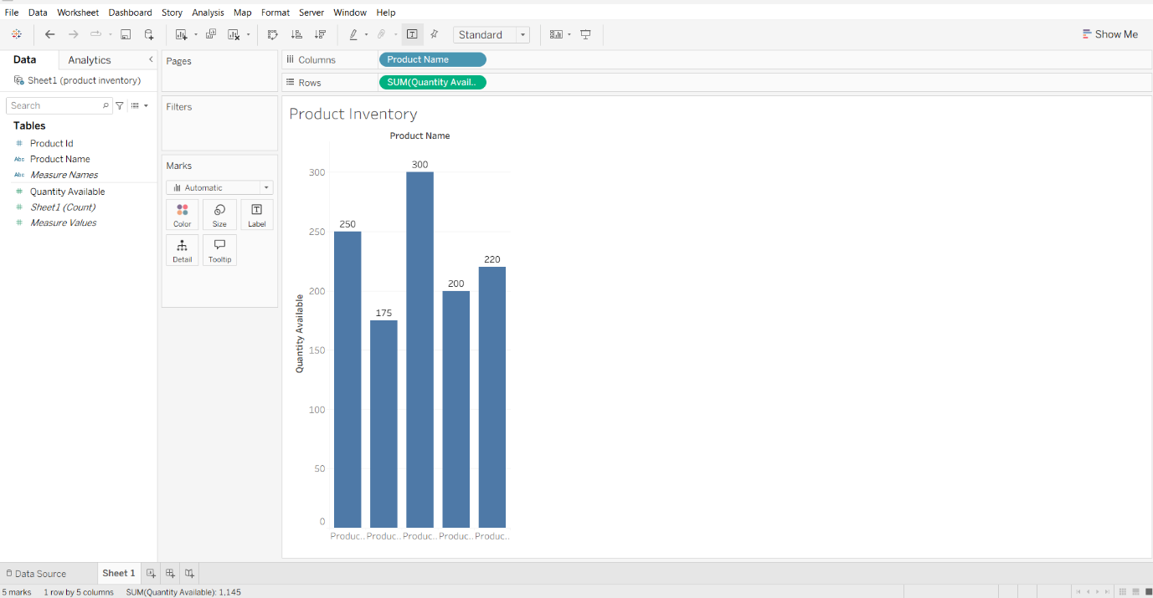

2. Procedure to Create a Stacked Bar Chart
1. Create a New Worksheet.
2. Drag Product Name to the Columns shelf.
3. Drag Quantity Available to the Rows shelf.
4. Select Bar from the Marks card.
5. Drag Product ID to the Colour shelf.
6. Go to Analysis → Stack Marks → On.
7. Rename the chart title as "Quantity Available by Product".
8. Save the worksheet.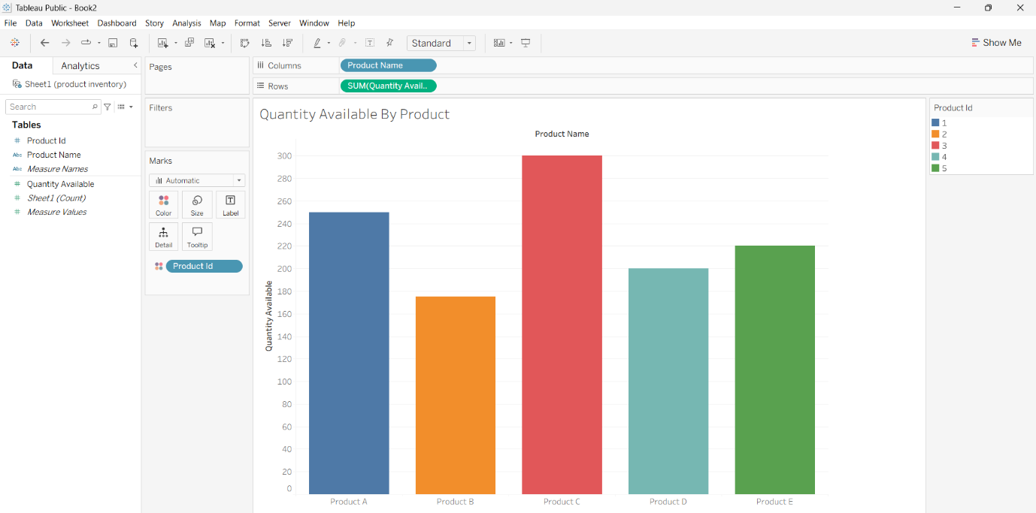
3. Procedure to Create a Scattered Plot
1. Create a New Worksheet.
2. Drag Product ID to the Columns shelf.
3. Drag Quantity Available to the Rows shelf.
4. Select Circle from the Marks card.
5. Drag Product Name to the Label shelf.
6. Rename the chart title as "Quantity Available by Product".
7. Label the X-axis as Product ID and the Y-axis as Quantity Available.
8. Save the worksheet.

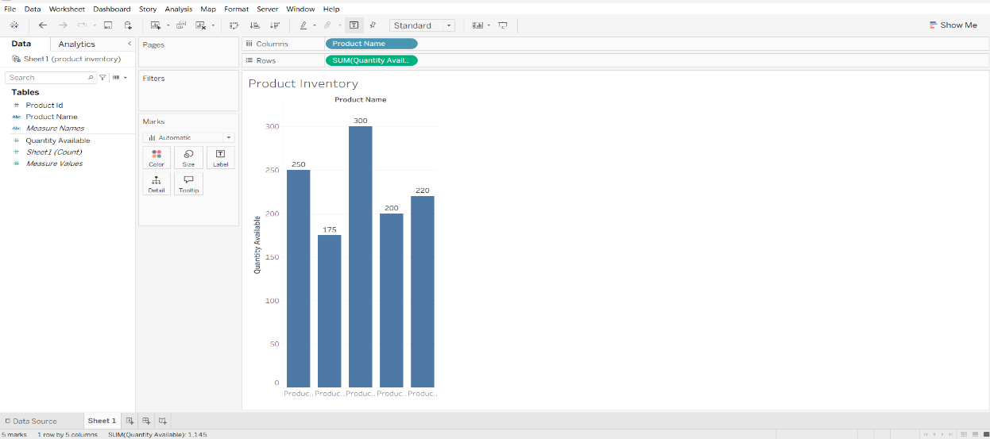
4. Procedure to Create a Dash Board
1. Click the New Dashboard icon.
2. Set the dashboard size to Automatic.
3. Drag the Bar Chart worksheet to the dashboard.
4. Drag the Stacked Bar Chart worksheet to the dashboard.
5. Arrange the charts neatly.
6. Rename the dashboard title as "Product Inventory Dashboard".
7.Save the Dashboard
.